**Laptop Request catalog item**

Team id:

Team Members:

Leader: Divya.S

Team Member 1: Gayathri.B

Team Member 2: Janani.J

**Problem Statement**

Employees need a fast, reliable way to request laptops. The existing process is manual, slow, and error-prone: forms aren’t dynamic to guide users, required information is often missed, there’s no simple reset option, and changes aren’t tracked for controlled deployment.

**Objective**

To streamline and automate the laptop request process by creating a dynamic, user-friendly Service Catalog item in ServiceNow.

To eliminate manual, error-prone methods by implementing guided forms, conditional logic (UI policies), and reset functionality.

To ensure all configuration changes are properly tracked and transferable between environments through update sets.

To improve efficiency, accuracy, and governance in laptop provisioning requests.

**Skills Demonstrated**

**1. ServiceNow Configuration**

Creating and managing Service Catalog Items.

Designing and adding variables (form fields) for structured data collection.

**2. UI Policies & Policy Actions**

Implementing dynamic form behavior (show/hide fields, mandatory conditions).

**3. UI Actions (Client-side Scripting)**

Writing client-side scripts for enhanced usability (e.g., reset form button).

**4. Update Set Management**

Capturing, exporting, importing, and committing update sets for controlled deployment.

**5. Testing & Validation**

End-to-end testing of catalog items and workflows to ensure correct behavior and user experience.

**6. Problem-Solving & Process Automation**

Analyzing manual processes and transforming them into efficient, automated solutions.

**TASK INITIATION**

Milestone 1: Update set

Activity 1: Create Local Update set

1. Open **ServiceNow**.
2. Click on **All** and search for **Update Sets**.
3. Under **System Update Sets**, select **Local Update Sets**.
4. Click on **New**.
5. Enter the details to create an update set with the name **“Laptop Request”**.
6. Click **Submit**, then select **Make Current**.
7. By making it current, the update set gets activated.

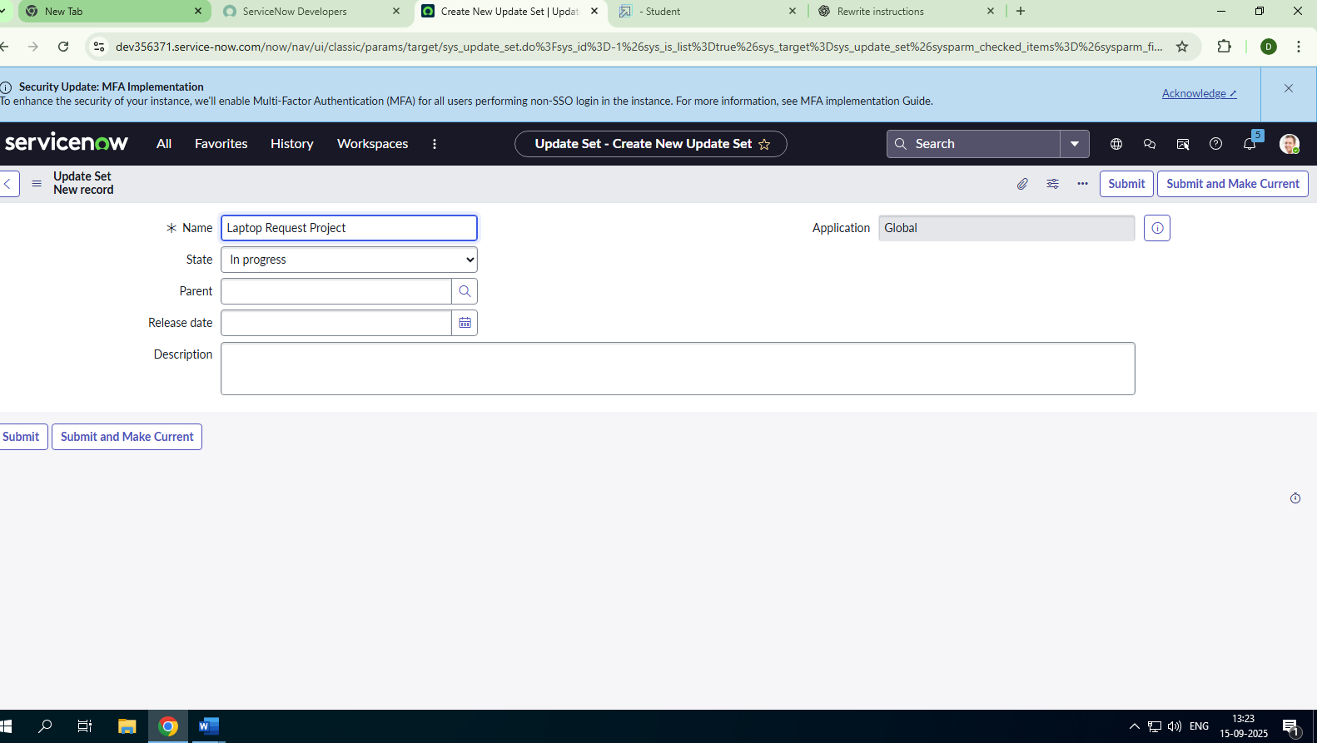

Milestone 2: Service Catalog Item

Activity 1: Create Service Catalog Item

1. Open **ServiceNow**.
2. Click on **All** and go to **Service Catalog**.
3. Under **Catalog Definitions**, select **Maintain Items**.
4. Click on **New**.

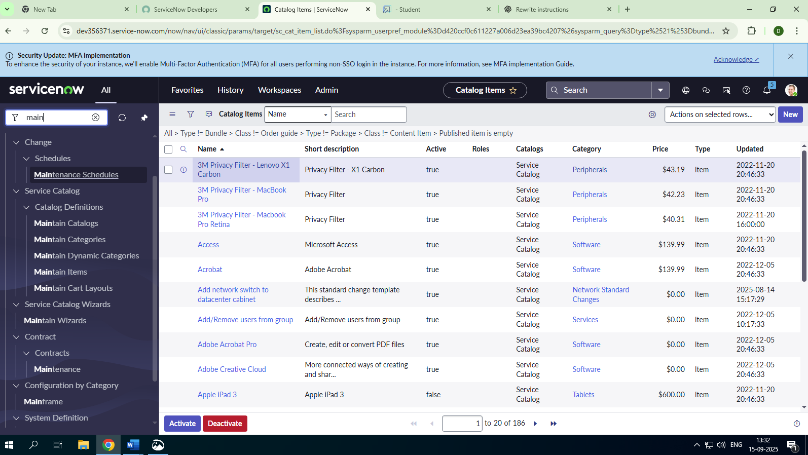

1. Fill in the details to create a new catalog item:

* **Name**: Laptop Request
* **Catalog**: Service Catalog
* **Category**: Hardware
* **Short Description**: Use this item to request a new laptop

6.Click **Save**.

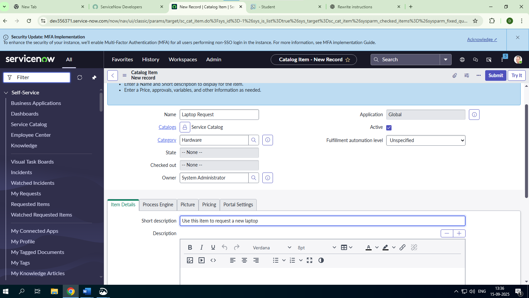

Activity 2: Add Variables

**Step 1:**

* After saving the catalog item form, scroll down to the **Variables (Related List)** section.
* Click **New** and enter the details for each variable as shown below:

1. **Variable 1: Laptop Model**
   * Type: Single Line Text
   * Name: laptop_model
   * Order: 100
   * Click **Submit**

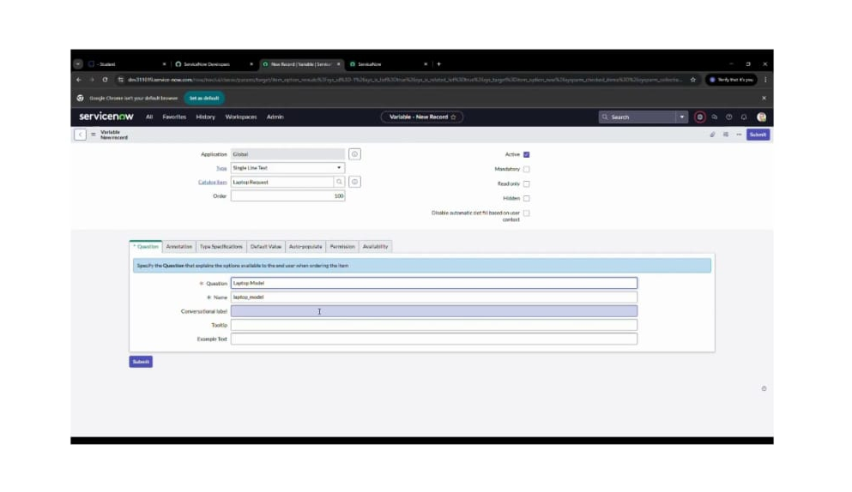

1. **Variable 2: Justification**
   * Type: Multi Line Text
   * Name: justification
   * Order: 200
2. **Variable 3: Additional Accessories**
   * Type: Checkbox
   * Name: additional_accessories
   * Order: 300
3. **Variable 4: Accessories Details**
   * Type: Multi Line Text
   * Name: accessories_details
   * Order: 400

*(Repeat the same process of clicking* ***New*** *to add each variable.)*

**Step 2:**

* Once all variables have been added, they will appear under the newly created catalog item.
* Finally, click **Save** on the catalog item form

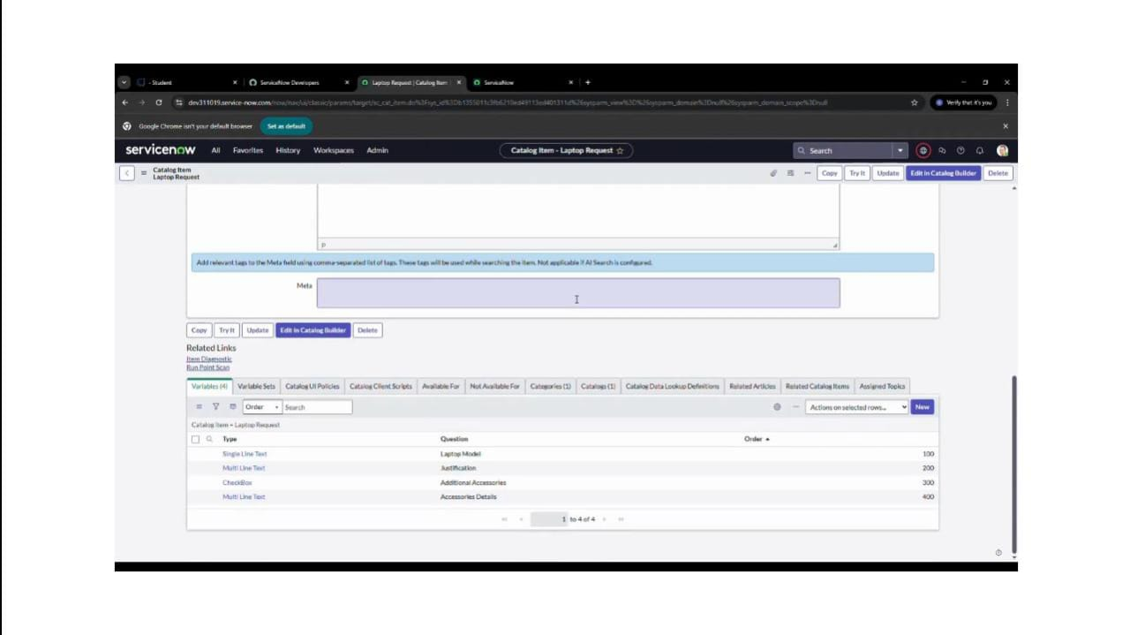

Milestone 3: UI Policy

Activity 1: Create catalog UI policies

1. Click on **All** and search for **Service Catalog**.

2. Under **Catalog Definitions**, select **Maintain Items**.

3. Search for **“Laptop Request”** (the catalog item created earlier).

4. Open **Laptop Request** and scroll down to the **Catalog UI Policies** related list.

5. Click **New** and fill in the details:

* **Short Description**: Show accessories details
* **Catalog Condition (When to Apply)**:
  + Field: additional_accessories
  + Operator: is
  + Value: true

6. Click **Save** (do not click Submit).

7. Scroll down to the **Catalog UI Policy Actions** related list.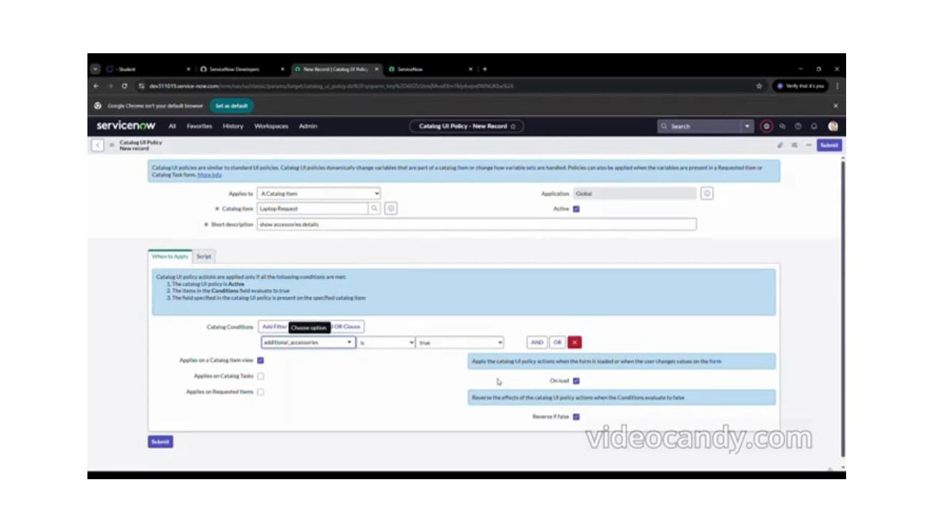

8. Click **New** and enter the following:

* **Variable Name**: accessories_details
* **Order**: 100
* **Mandatory**: True
* **Visible**: True

**9**. Click **Save**, then click **Save** again on the Catalog UI Policy form.

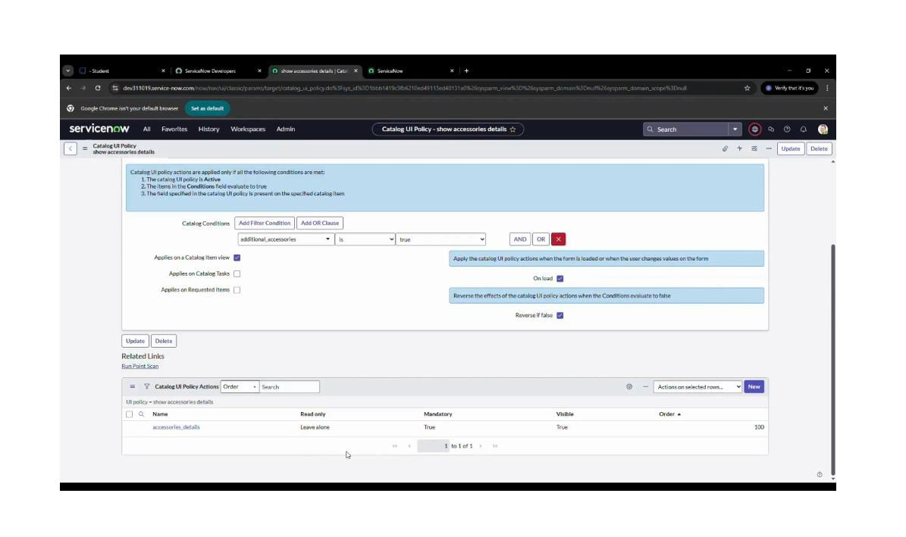

Milestone 4: UI Action

Activity 1: Create UI Action

1. Open **ServiceNow**.

2. Click on **All** and search for **UI Actions**.

3. Under **System Definition**, select **UI Actions**.

4. Click **New**.

5. Fill in the following details to create a new UI Action:

* **Table**: Shopping Cart (sc_cart)
* **Order**: 100
* **Action Name**: Reset form
* **Client**: *Checked*

6. In the **Script** field, enter the following code:

function resetForm() {

g_form.clearForm(); // Clears all fields in the form

alert("The form has been reset.");

}

7. Click **Save**.

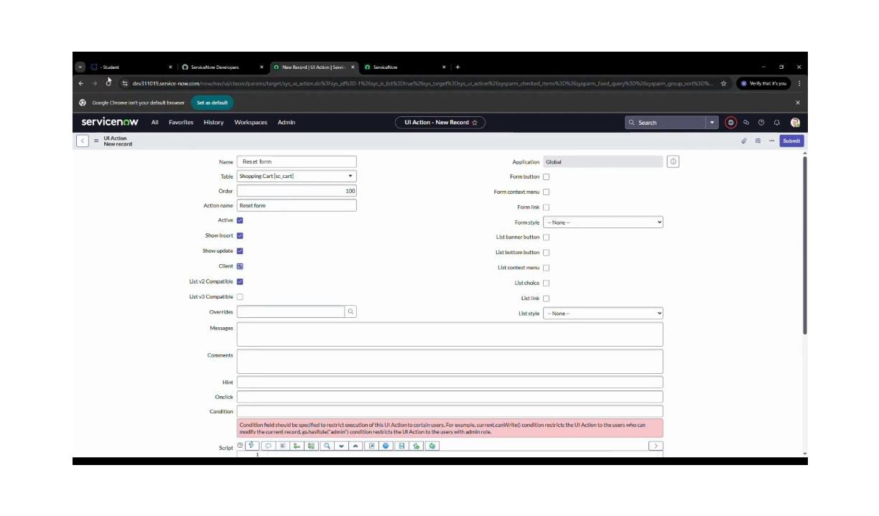

Milestone 5: Export update set

Activity 1: Exporting changes to another Instances

1. Click on **All** and search for **Update Sets**.
2. Select **Local Update Sets**.
3. Open the update set you created (e.g., **“Laptop Request Project”**).
4. Change the **State** to **Complete**.
5. In the **Updates** related list tab, you can view all the updates captured under this update set.
6. Click **Export to XML** — this will download the update set as an XML file.

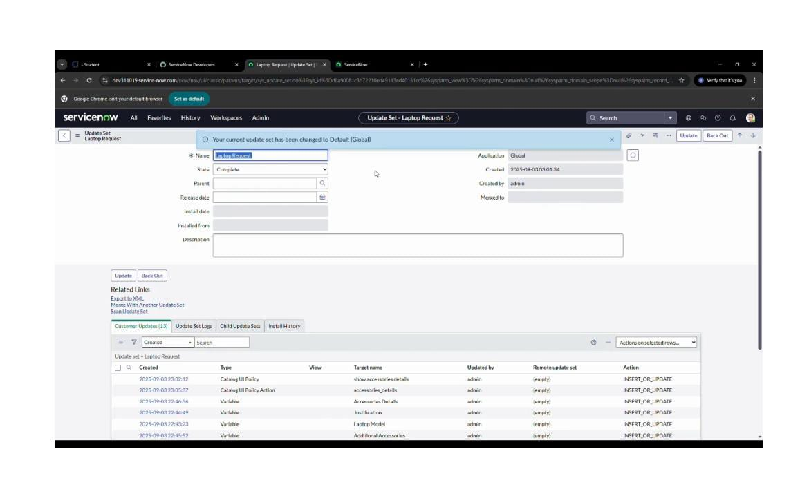

Milestone 6: Login to Another Instances

Activity 1: Retrieving the update set

1. Open another ServiceNow instance in an **Incognito window**.
2. Log in using your credentials.
3. Click on **All** and search for **Update Sets**.
4. Under **System Update Sets**, select **Retrieved Update Sets**.
5. The retrieved update set list will open. Scroll down and click **Import Update Set from XML**.
6. Upload the previously downloaded XML file.

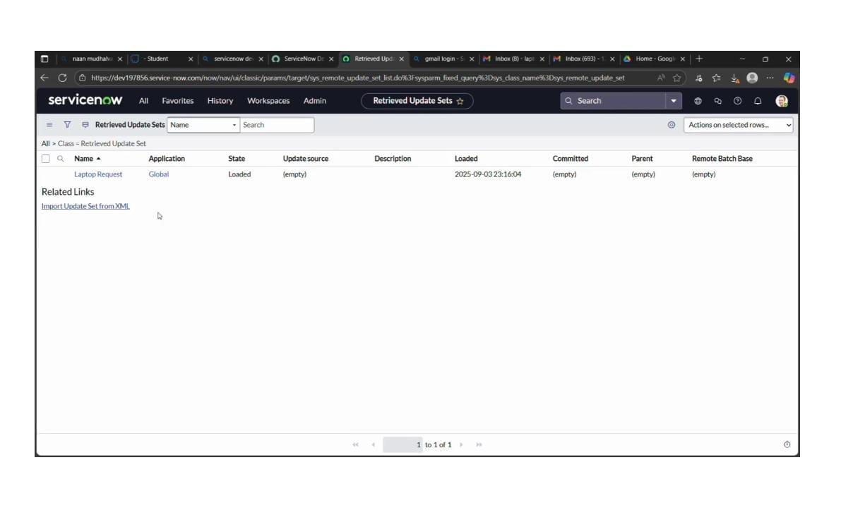

1. Click **Upload** to complete the import.
2. Open the retrieved update set **“Laptop Request Project”**.

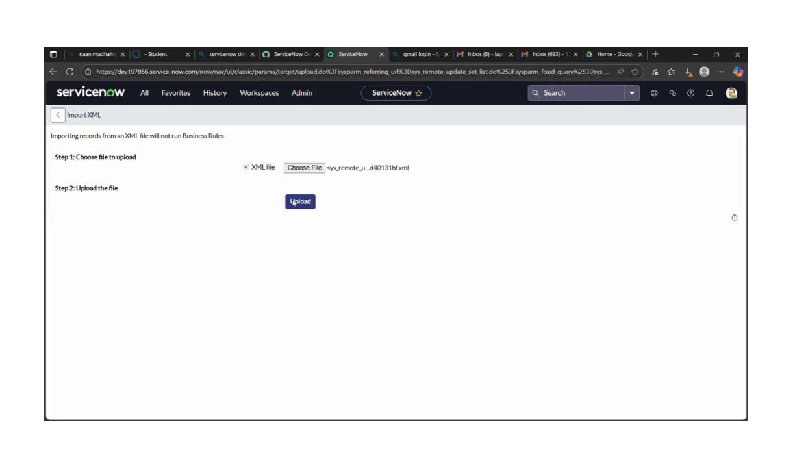

1. Click **Preview Update Set**, then click **Commit Update Set**.
2. Check the **Updates** related list to verify.

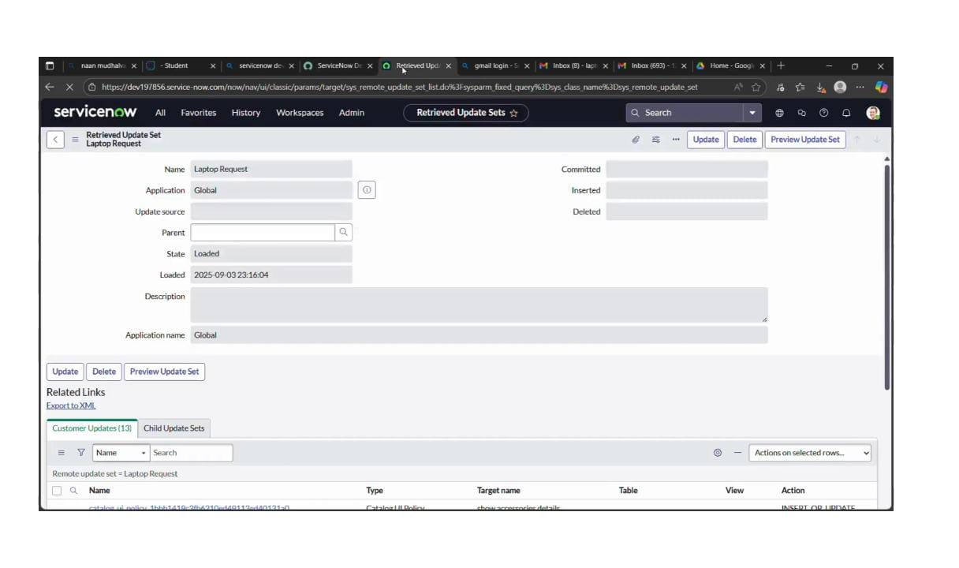

Milestone 7: Testing

Activity 1: Test Catalog Item

1. In the **target instance**, search for **Service Catalog** in the Application Navigator.
2. Under **Service Catalog**, select **Catalog**.
3. Open the **Hardware** category and search for the item **“Laptop Request”**.
4. Select and open the **Laptop Request** item.

The form displays three variables initially.

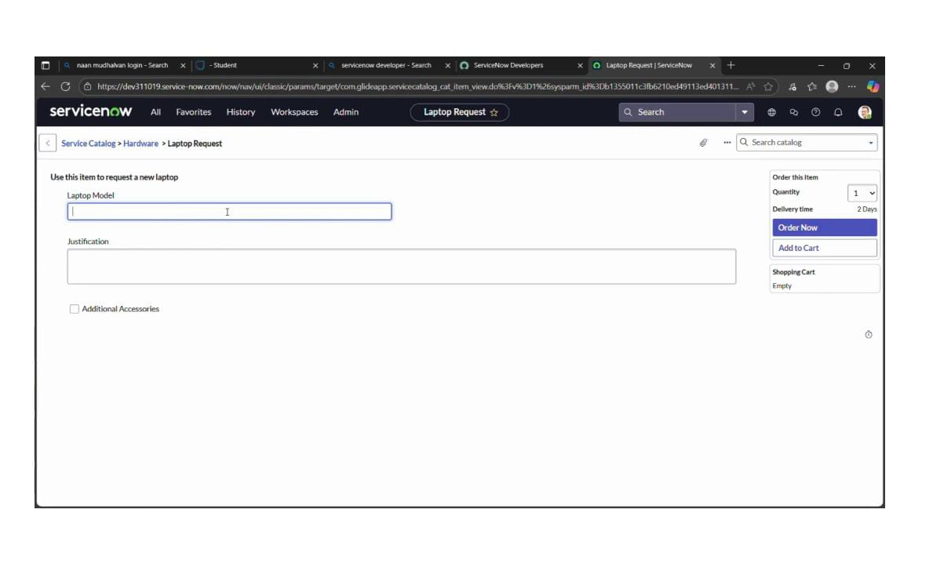

1. As per the scenario:
2. When the **Additional Accessories** checkbox is selected, the **Accessories Details** field becomes **visible** and is set as **mandatory**.
3. Verify the behavior — the result matches the requirements.

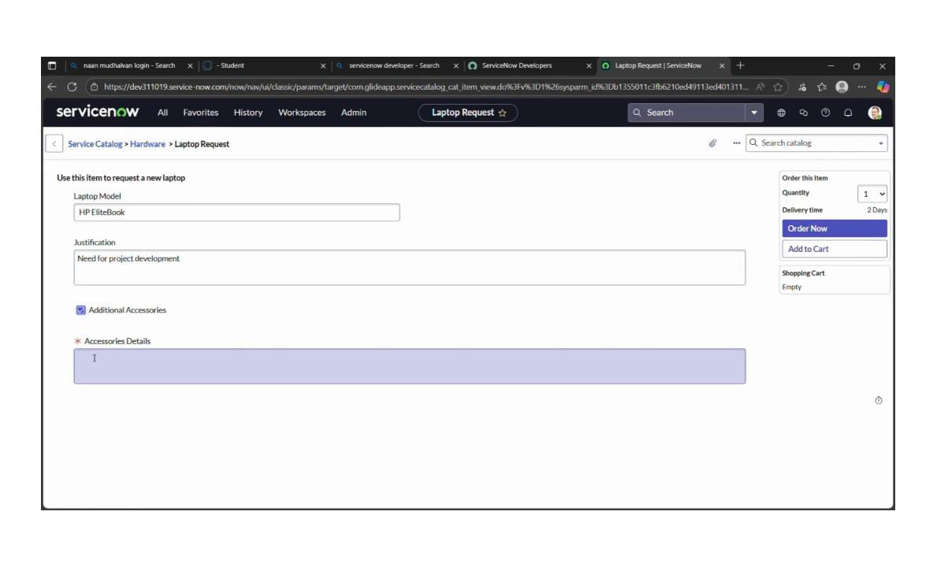

Conclusion:

The **Laptop Request Catalog Item Project** simplifies and streamlines the laptop request process within the organization by utilizing ServiceNow’s Service Catalog features. With a dynamic and user-friendly catalog item, the project provides employees with an intuitive interface that minimizes errors and enhances efficiency. This initiative highlights how ServiceNow can transform manual, error-prone tasks into automated, efficient, and user-focused solutions. Beyond improving service delivery, it also boosts employee satisfaction by offering a modern and seamless request experience.